NAME : ADITYA UPADHYAY
CSE A 3rd Year
ROLL : 2400290100025
1 : Repository URL:
https://github.com/UP-Aditya/github-skills-challenge

2 : PR URL:
https://github.com/UP-Aditya/github-skills-challenge/pull/2
3 : Action Tab Github
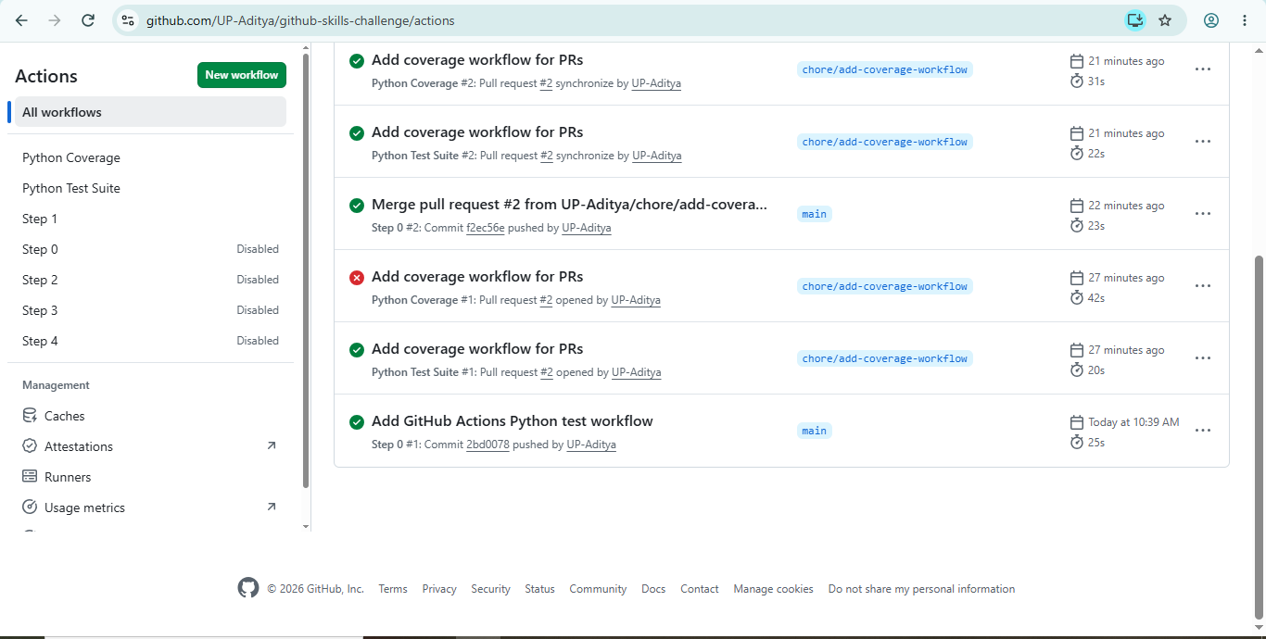

4 : Coverage Report
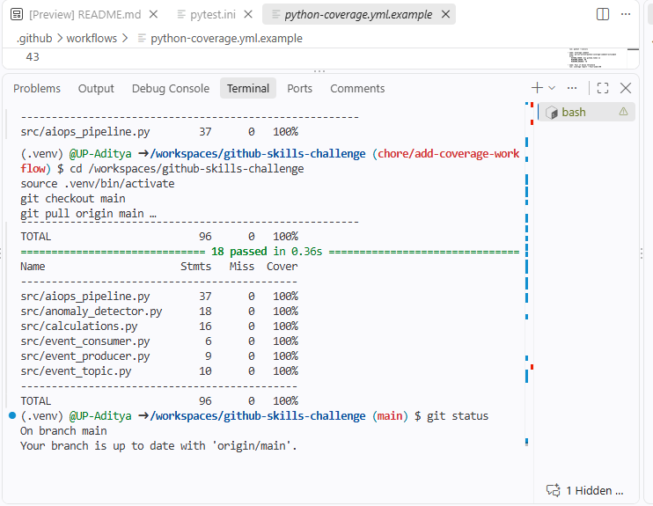

5 : Python Test Suite & Coverage
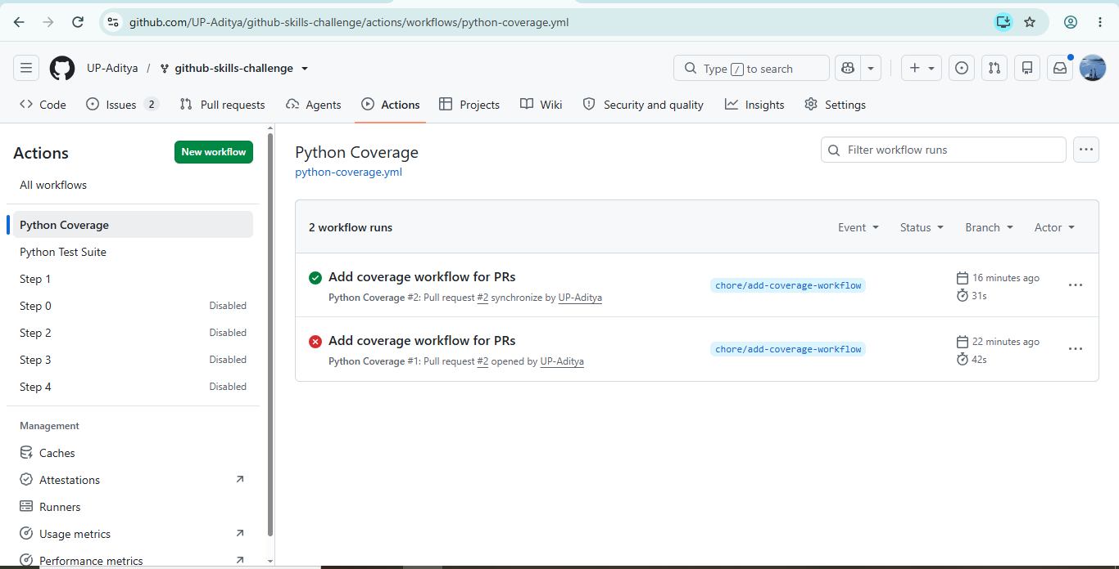

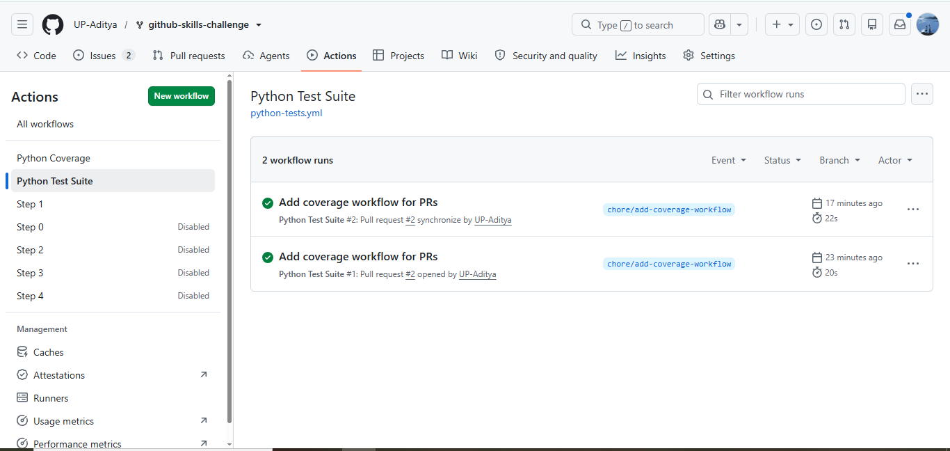

6 : Github Page
